# **MICROPROCESSOR: A REVOLUTION TO DIGITAL TECHNOLOGY**

# **INTRODUCTION:**

# Microprocessor is the brain of computer just like how the brain serves as the functioning mechanism in your body. It takes control over each part of the function in computers, mobile phones, and most of the electronic gadget we use in our day-to-day life.

# Microprocessors are used in an area of requirement that requires some sort of processing like traffic lights, remotes, computers, phones, etc. These processors have an algorithm, and they work in a previously programmed manner according to the instruction given.

**WHERE AND HOW THE INVENTION MICROPROCESSORS DID TAKES PLACE?**

Microprocessors are first invented 50 years ago and invented by intel company in 1971 of 4-bit processor. Coming to the components of microprocessor, its components are:

* **ALU**
* **REGISTER**
* **CONTROL UNIT**

**ALU** (Arithmetic and Logic Unit) are the building blocks they perform all mathematical and logical calculations on the data that has been fed to it like

* Math: addition, multiplication, subtraction, etc.
* Logical: and, or, and not operations, etc.

**REGISTERS** are the temporary data storage locations in the microprocessors depending upon the need they either hold data or point in the direction where the data is located.

They are divided into three categories:

* General purpose registers
* Specific registers
* Memory registers

**CONTROL UNIT** controls the operations in the microprocessors it dictates how the internal memory of the computer should respond to the given instructions and controls the flow of data between the microprocessor and the system.

**Microprocessors are further connected to the input devices, memory unit, and output devices.**

**WHY DO WE USE MICROPROCESSORS?**

A microprocessor transmits, receives and interprets the data needed for the device. It is an integrated circuit that comprises of arithmetic, logic and control circuitry required to explicate the instructions from a computer program. In computers with microprocessors, the entire CPU is present in one or a small number of integrated circuits, which perform basic functions of a computer. So, it is considered to be the fundamental component of a computer.

Microprocessor is important because it involves 3 steps, fetch, decode and execution. Fetching is the process of accessing the instructions present inside the program in the memory by the microprocessor, while understanding the instructions that are obtained from the memory is known as decoding and the process of performing with an accurate operation that is supposedly to be done by the system is called execution. This all-inclusive process of a microprocessor is known as the instruction cycle.

A microprocessor is capable of doing numerous things such as calculations, word processing and can be used for communication through the internet or telephones. The other important advantage of having microprocessor is its speed, with a speed of 3Hz it can nearly perform 3 billion tasks per second. For the device to work properly, it itself need to communicate with the further parts of the machine to display the output data of any program based on the input given to the device.

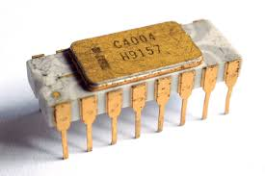 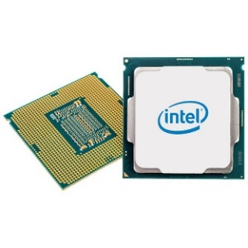

**INTEL 4004 INTEL i9**

Originally invented in 1971 and developed during the 1970’s, microprocessors quickly became popular at being the central processor of personal computers. In the early days vacuum tubes were used which could carry only few arithmetic operations in course of time as the technology developed microprocessors could do the tasks given within fraction of seconds. It can perform multiple tasks by avoiding the transistor which usually performs several tasks individually.

Microprocessors also consume less amount of power which makes them more efficient. They are portable, reliable and versatile. They also play supporting roles within larger computers as smart controllers for storage devices, high-speed printers and graphic displays. The applications of microprocessors are varied, such that, they can be found in wristwatches, gaming consoles, other electronics and even automobiles. They can be used to control everything from consumer appliances to smart weapons making them a landmark development in computer technology.

**TYPES OF MICROPROCESSORS:**

Different types of microprocessor are.

**1) CISC**

CISC or Complex Instruction Set Computer is capable of executing single instructions using several low-level functions. These low-level functions can be used for several operations like load from memory, memory store or any kind of arithmetic operations. Complex computations can also be performed. Less RAM usage

**2) RISC**

RISC or Reduced Instruction Set Computer can be used to work with fewer instruction cycles as compared to the CISC. It is made up of a set of simple instructions. It consists of large number of registers. It uses more RAM. RISC is the most commonly used processor.

**3) Superscalar Processor**

Superscalar Processor is capable of implementing instruction-level parallelism and that too within a single processor. It can execute more than one instruction per clock cycle. As a result, this kind of processor is extremely fast and gives more throughputs as compared to primitive scalar processors.

**4) Application Specific Integrated Circuit**

This type of integrated circuit is used for specific purposes only. They can be used in a digital voice recorder or a bit coin miner. The design is extremely modern, and they may include the entire microprocessor in a single chip. Apart from the above-listed, there are a number of special processors as well. Some of them are discussed below.

**5) Coprocessor**

A coprocessor can be used to handle practical functions faster than the normal microprocessor. One such processor is the 8087 processor.

**6) Input/output Processor**

Input/output type is mainly used to control IO devices. One such example is the DMA control. This type of processor has its own memory.

**7) Digital Signal Processor (DSP)**

Digital Signal Processor requires a number of components like the term memory, input/output and program memory. We can use this processor to process analog signals to digital signals.

**8) Graphic Processor**

Graphics Processors are specially designed processors for graphics. Intel has developed Intel 740-3D graphics chip. It is optimized for Pentium II PCs, using a hyper pipelined 3D architecture with additional 2D acceleration. Like most 3D graphics chips, the I-740 will be marketed in performance, not the mainstream category. It is designed mostly for such heavy multimedia uses as games and movies.

**9) Bit-Slice Microprocessor (BSM)**

Bit-Slice Microprocessor or BSM is a special type of microprocessor whose main purpose is to form a microprocessor of desired word size by combining identical BSMs. It is available in 2-bit, 4-bit, 8-bit, 16-bit and 32-bit word size. And two or more than two identical BSMs are cascaded together to form a processor of conventional (8,16,32) or unconventional (6,10,12) word size.

**WORKING OF MICROPROCESSORS:**

Microprocessor is main part of microcomputer which is famously known as CPU.it is simply a chip which is capable of processing data. it controls all components for example human brain controls all parts of the body. likewise, the microprocessor controls all components of the computer component here is nothing but memory input and output devices and some external devices everything will be controlled by microprocessor.

Coming to its design and constituent microprocessor consists of an ALU which means (Arithmetic Logical Unit) register are and a control unit. As mentioned in the name ALU performs arithmetical and logical operations on the data received from an input device. Register arrays consist of registers identified by letters like B, C, D, E, H, L and accumulator. while the control unit controls the flow of data and instructions within the computer.

So, coming into the microprocessor working the microprocessor follows a sequence that is fetch, decode and then execute. here fetching means taking. Main work of the microprocessor was done by only using these Fetch, Decode, Execute.

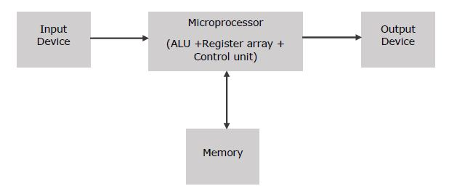

Initially the instructions are stored in the memory of the computer in a sequence. The microprocessor fetches those instructions from the memory then decodes it and executes those instructions till stop instruction is reached. Later it seems the result in binary to the output port, between these processes the register stores the temporary data and arithmetic logical unit performs computing functions.

The processor will understand only the binary information that is , 1’s and 0’s that is we call it as a machine language whatever the information we are typing is the high level language. the high-level language converts into assembly language and later converts into machine language that machine language is in the form of 1’s and 0’s.

So, the microprocessor will fetch the information and after that the instruction will be decoded as 1’s and 0’s and after it executes the operation that is performing the operation. a microprocessor can be classified into 3 categories are RISC processors, CISC processors and special processors and we will study them at higher grades. Basically, a microprocessor can perform multiple data type formats like binary BCD, ASCII, signed and unsigned numbers. Therefore, a microprocessor takes input from input devices, process it as per instructions given in the memory and produces output.

**Common Terms used in a Microprocessor**

Here are some common terms that we will use in microprocessor field.

1. **Instruction set** : It will give instruction that micro processor. simple word It will covert all the words into binary then micro processor can understand.
2. **Band Width:** No Of Bits processed in a single process
3. **Clock Speed**: It decides the number of operations per second the processor can perform. It is expressed in megahertz or gigahertz.
4. **Cache memory**: It is a random access memory that is integrated into the processor. So the processor can access data in the cache memory more quickly than from a regular RAM (Random Access Memory).
5. **Bus:** It is a set of conductors intended to transmit data, address or control information to different elements in a microprocessor. Usually a microprocessor will have 3 types of buses : Data Bus, Control Bus and Address Bus. An 8-bit processor will be using 8-bit wide bus.
6. **Word Length**: It depends upon the width of internal data bus, registers, ALU, etc. An 8-bit microprocessor can process 8-bit data at a time. The word length ranges from 4 bits to 64 bits depending upon the type of the microcomputer.
7. **Data types**: micro processor will convert our input into different types

Eg: ascii, binary, BCD etc..

**CORE OF A MICROPROCESSOR:**

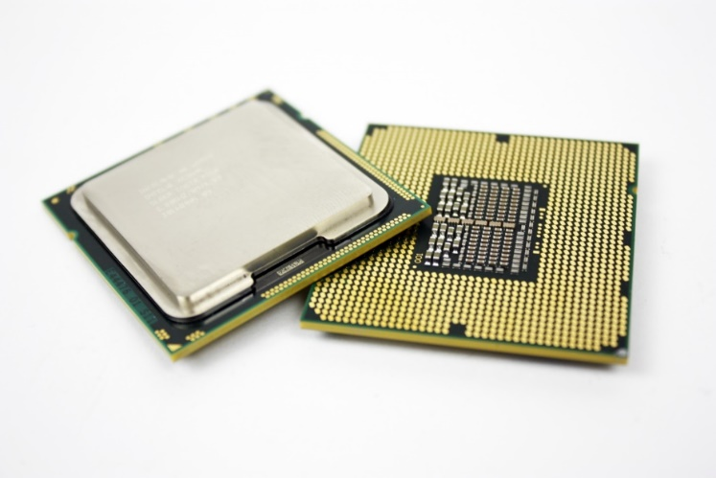

**Core**

* A Core gets guidelines and performs computation or activities. A CPU can have numerous centers.
* A processor with two centers is known as a double center processor. A processor with four centers is called quad-center; six centers, Hexa-center; eight centers, octa-center. Starting at 2019, somewhere in the range of two and twelve centers most of buyer CPUs highlight.
* One center of a CPU can perform tasks independently from the others. Or then again, more than one center may cooperate to perform corresponding with procedure on a shared arrangement of information.
* Memory used to before RAM as far as we might be concerned today. politeness of Rutherford Appleton Laboratory, the image is an illustration of a memory center utilized in the Atlas 1 PC that was 12-centimeters square and had 64 centers.
* Short for a center dump, a center should advise to a PC, PC gadget, network gadget, or other related item blunders and can't show an appropriate mistake message. a huge posting of information is appeared to help discover what's causing the issue, when this issue happens.
* In a solitary actual bundle, a multi-center processor executes multiprocessing. The engineer may couple centers in a multi-center gadget firmly or freely.
* The regular organization geography used to interconnect centers incorporates transport, ring, and two-dimensional lattice.
* Indistinguishable centers are remembered for Homogeneous multi-center frameworks; heterogeneous multi-center frameworks have centers that are not indistinguishable.
* Centers in multi-center frameworks may execute structures, for example, VLIW, superscalar, vector, or multithreading by Just likewise with single-processor frameworks.
* Broadly useful, installed, network, computerized signal handling (DSP), and illustrations (GPU). Center check goes up to even handfuls, and for particular chips more than 10,000, and in supercomputers (i.e., groups of chips) the tally can go more than 10 million and numerous application spaces are broadly utilizing Multi-center processors.

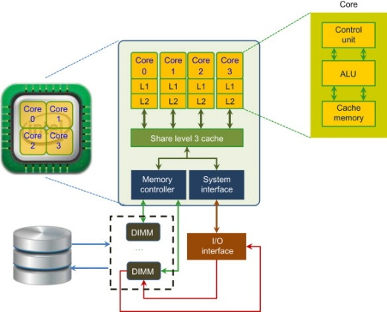 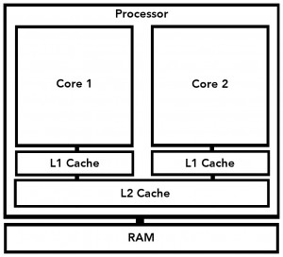

1. **Single-core**

It is the first and most seasoned sort of CPU which is accessible and utilized in generally close to home and official PCs. The single-center CPU can execute just each order in turn and it can't perform performing various tasks.

1. **Dual-core CPU**

A processor with two centers. It is a solitary CPU center that can work like a double CPU acting like one bye included two in number centers. In contrast to the CPU with a solitary center, the processor should switch to and fro inside a variable exhibit of information streams and if or more string is executed, the double center CPU adequately can deal with the performing multiple tasks viably.

1. **Quad-core CPU**

A processor with four centers. On a solitary CPU, the quad-center CPU is a refined model of various center CPU highlights and plan with four centers. like double center CPU, in the middle of the centers that partition the remaining burden, and quad-center empowers for powerful performing various tasks.

1. **Hexa-Core processors**

A processor with six centers It is another numerous center processor that is accessible with six centers and can execute the undertaking. It works quickly than quad-center processors.

1. **Octa-core processors**

A processor with eight centers. The double center is created with two centers, four centers are underlying quad-center, Hex accompanies six centers where the octa processors are created with eight autonomous centers to execute a powerful undertaking that is effective and even acts quickly than quad-center, hex-center, and double center processors.

1. **Deca-core processors**

A processor with ten centers. In this processor a twofold center incorporates two centers, 4 centers are accessible with quad centers, six centers are accessible in hexacore processors. Deca-center is having ten free frameworks that are conveyed to execute and deal with the errand that is effective as of recently different processors that are created**.**

**MOORE’S LAW:**

Moore’s law refers that the number of transistors in microchip doubles every two years, although the cost of computers is halved. It tells that we can expect the speed and capability of our computers to increase every couple of years, and we will play less for them.

In 1965 Gordon E. Moore, the co-founder of intel, observed and postulated that the increase in postulates is only restricted to two years also he declared that the growth of the transistors is exponential. However, now a days the doubling of the transistors is way faster than the expected range of two years.

He also claimed and the law states and implies is computers and all machines which work under computers will become small and cheaper as the time goes by. As the time went by all the transistors and microprocessors became smaller and faster and cheaper.

**Benefits of Moore’s law**:

* COMPUTING
* ELECTRONIC
* ALL SECTORS BENEFIT
* The transistors became more efficient, smaller, faster and cheaper as partly because low labor costs and decrease in prizes of semiconductors.
* In every aspect we can observe that there is only benefit and no loss for high-tech companies as these mobile phones computers and even games do not work without these tiny processors.
* Many sectors got benefitted by this law as now a days everything depends on internet and these computers work only with these chip processors.

**GRAPH:**

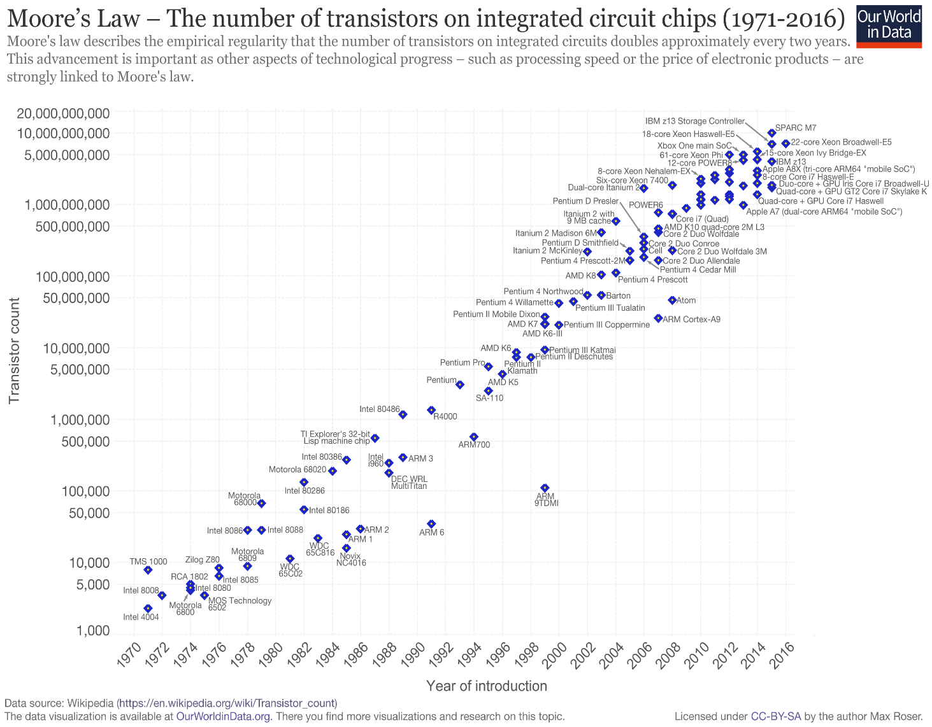

Moore observed that the number of transistors on a computer chip was doubling about every 18–24 months. As shown in the logarithmic graph of the number of transistors on Intel's processors at the time of their introduction, his “law” was being obeyed.

**About imminent death of Moore’s law:**

As the scale of chip components gets closer and closer to that of individual atoms, it's gotten harder to keep up the pace of Moore's law. It's now more expensive and more technically difficult to double the number of transistors and the processing power for a given chip every two years.

In 2007 interview Moore he himself stated that it will be difficult for any material to manufacture as we are pushing every element together and at some point we need to stop making things smaller.

As the time flies, they are telling that Moore’s law will be replaced by Neven’s law. Technology is developing and there will be a replacement of microprocessors too. Moore’s law revolutionized the computer technology, and we feel the lasting impact and benefits from Moore’s law.

**CONCLUSION:**

In conclusion, a microprocessor is one of the most exciting technological innovations in electronics since the appearance of the transistor in 1948. This wonder device has not only set in the process of revolutionizing the field of digital electronics, but it is also getting entry into almost every sphere of human life. Applications of microprocessors range from very sophisticated spy satellites, complicated medical surgeries to simple game machines and even toys. The developments in microprocessors since invention of Intel 4004 in 1971 have been in the direction of

**(a) improving architecture,**

**(b) improving instruction set,**

**(c) increasing speeds,**

**(d) simplifying power requirements and**

**(e) incorporating more and more memory space**

Latest news in the industry is that Intel’s new hybrid CPU and 3D stacking technology will transform PCs and mobile devices forever. This combo will bring unprecedented power, battery life and flexibility to future generations of mobile phones, tablets, 2-in-1 convertibles and even traditional laptops.

**References**

<https://www.techwalla.com/articles/why-is-a-microprocessor-important>

<https://www.brainspire.com/blog/what-is-a-microprocessor-and-how-does-it-work>

<https://www.javatpoint.com/types-of-microprocessors>

<https://www.computerhope.com/jargon/c/core.htm#:~:text=A%20core%2C%20or%20CPU%20core,eight%20cores%2C%20octa%2Dcore>.

<https://www.tutorialspoint.com/microprocessor/microprocessor_overview.htm#:~:text=How%20does%20a%20Microprocessor%20Work,%2C%20Decode%2C%20and%20then%20Execute.&text=The%20microprocessor%20fetches%20those%20instructions,binary%20to%20the%20output%20port>.

<https://www.investopedia.com/terms/m/mooreslaw.asp>

<https://www.techproviderzone.com/devices/hybrid-cpus-are-coming-get-ready-for-the-mobile-revolution>

<https://www.electropages.com/blog/2019/01/replacing-silicon-cpu-future-microprocessors>

**Crewmates:**

Boudhik Shaj (AM.EN.U4CSE20317)

Bangari Vivekraj (AM.EN.U4CSE20315)

Beeram Sai Sarvagna (AM.EN.U4CSE20316)

Chandaka Sai Krishna Kumar (AM.EN.U4CSE20318)

Chilumuru Siri Sanjay (AM.EN.U4CSE20319)

Dadi Koushik (AM.EN.U4CSE20320)

Devesh Kumar V V (AM.EN.U4CSE20321)